**My Blog Software Requirements**

Goals

1. Create a blog to be able to share stories and knowledge with others.

User Stories

As a <User> , I want <Goal> so that <some reasons>

TASK: Complete 3rd user story for being able to add a new post

1. As a viewer, I want to see the list of blog posts so that I can see the blog and topics for me to choose

2. As a viewer, I want to view an individual blog post so that I can read all of its content.

3. As a Admin, I want to add a new blog post so that I can easily add content to my blog .

User Flow

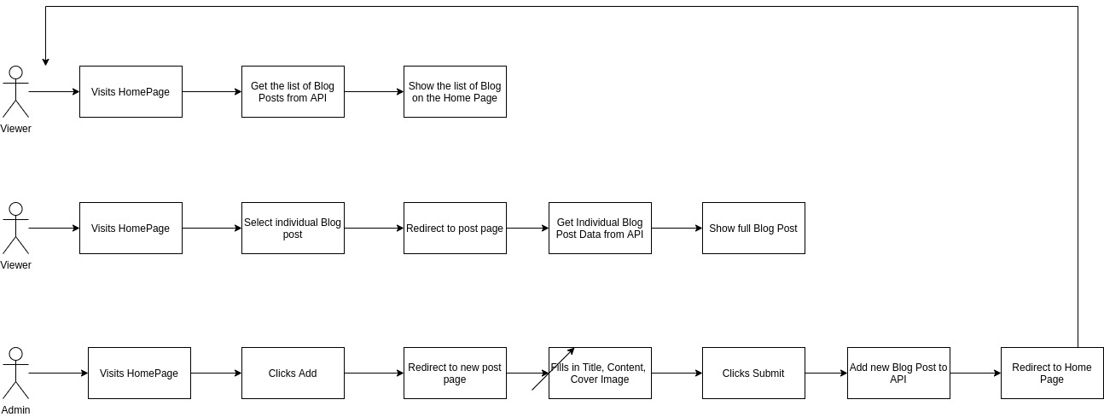

Business Requirement

Pages

* Home Page
* Individual Blog Post Page
* New Post Page

Home Page

* Display use Profile Image
* Display list of Blogs with Title, Date, Content
* Limit the Blog Text to a certain Height

Individual Blog Post Page

* Show the cover image, title, content added date
* Allow the user to go back to Home Page

New Post Page

* Allow user to fill in title, content, and select the cover image
* Store the added date

Technical Requirement

* Front End using JavaScript
* Back End using NodeJS
  + Rest API
* Database
  + JSON
* API Endpoints
  + Get list of Blog Posts
    - “api/posts”
  + Get individual Blog
    - “api/posts/post_id”
  + Pot Blog Post
    - “api/posts”